**Global**

* **Page header**
  + (Sindeo Logo) *in upper left corner*
  + Need help? Call us at 1-855-SINDEO1 (1-855-746-3361) *in upper right corner*
  + Menu bar:
    - Categories
      * Learn
        + Mortgage Profile Builder
        + Mortgage Types
        + Today’s Rates
      * Apply
      * About Us
        + Our Mission
        + Areas We Serve
        + Meet Our Advisors
        + Leadership Team
        + Careers
        + Contact Us
    - Upper Menu Bar:
      * Search (expands when you click into it)
      * Chat
        + Opens panel with photos of advisors that are online

Includes headshot, profile and status (online, offline)

* + - * + Potentially powered by WorkFace <http://workface.com/> (Dan – do you know this company?)
      * Help (links to Contact Us)
    - Right below menu bar, include a button that says “Apply now”
    - References:
      * Need help reference:



www.quickenloans.com

* + - * Upper Menu reference:



http://www.smartermortgages.com/about-us/serve/

* + - * Expanding Search icon reference:



[www.moneypark.com](http://www.moneypark.com)

* + - * Chat Reference:

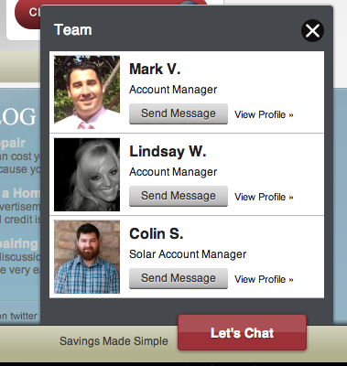

http://www.paramountequity.com/

* + - * Apply Now Button Reference:



[www.primelending.com](http://www.primelending.com)

* **Footer**
  + **Site map**
    - Same options as menu bar, but broken out with the sub-categories
  + **Social media**
    - Follow us on Facebook (link - https://www.facebook.com/pages/Sindeo/1374268079478117)
    - Follow us on Twitter (link - www.twitter.com/asksindeo)
    - Reference:
      * Site map at bottom of page:



[www.learnvest.com](http://www.learnvest.com) (bottom of page)

**Homepage**

* *Each module described below refers to a horizontal section of the page. See* [*www.learnvest.com*](http://www.learnvest.com) *or* [*https://thebatterysf.com/*](https://thebatterysf.com/) *for an example of what this looks like.*
* **First module: Page Intro**
  + **Header:** A better way to get a mortgage. Now in California.
  + **Sub-head:** At Sindeo, we believe that getting a mortgage doesn’t need to be such a pain. That’s why we’re reinventing the mortgage process to get you the most competitive rates in the shortest amount of time. Peace of mind included. Spend 5 minutes with our advisors today:
    - **Box 1:** Call us at 1-855-SINDEO1 (746-3361)
    - **Box 2:** Have us contact you:
      * *To create a clean form, all form fields do not need titles, but the text in grey that disappears when you click into the box.*
      * Form field 1 – First and last name (free entry)
      * Form field 2 – Phone number (free entry of a 10 digit number formatted as a phone number i.e. (646) 276-5342, text appears in red if not a valid phone number)
      * Form field 3 –E-mail address (free entry, appears in red if not a valid e-mail)
      * Form field 4 – I want to: (radio buttons)
        + Purchase a home
        + Refinance a mortgage

If Refinance selected, two more options pop up below: Change Rate, Cash Out (radio buttons)

* + - * Form field 5 – Timing:
        + Need a mortgage now!
        + Actively shopping
        + Just researching
      * Button - Submit
    - **Box 3:** Not yet ready?
      * Learn more about your options with mortgage profile builder:
      * Button – Mortgage Profile Builder
    - **Reference:**



www.jgwentworth.com

* **Second module: Who we are and what we do**
  + **Module:** Here’s how the we’re reinventing the mortgage process:
    - *Only show the bold text for the five bullets. Clicking on each one reveals the text below and a button that says “Apply Now”*
    - **More options, lower rates.** We have access to more lenders, mortgage products and programs, which allows us to offer more options to finance your home and save you money.
    - **Quick and simple process.** Our high-tech process is designed for speed and simplicity. Get pre-qualified in minutes and close your loan in 30 days or less.
    - **Personalized, expert care from start to finish.** Our advisors know how to get it done right from inquiry to closing. They collectively have closed billions of dollars of mortgages and have won countless awards. Get to know them… (link to Our Advisors page)
    - **Our interests are aligned with yours.** Our advisors are paid on a fixed basis, so they are fully focused on getting you the mortgage that best fits your needs.
    - **Safe and secure.** All of your data is encrypted with bank-level security and we never share your information without your permission.
* **Third module: Our Simple Process**
  + **Header:** Our Simple Process
  + **Sub-head:** Click on each of the steps below to learn more.
  + *Only show the five headers. Clicking on each one reveals the text below.*
  + **Module:**

**5**

**4**

**3**

**2**

**1**

|  |  |  |  |  |
| --- | --- | --- | --- | --- |
| **BUILD YOUR MORTGAGE PROFILE** | **GET PRE-QUALIFIED** | **SELECT LOAN AND LENDER** | **DOCUMENTS & DISCLOSURES** | **CLOSING** |
| Start by telling us about yourself and what you’re looking for. Learn more about types of mortgages, today’s rates and what you can afford in the process. | We’ll dive into your credit, income, and assets to determine your maximum borrowing power. We’ll also run automated underwriting to add Fannie Mae’s or Freddie Mac’s stamp of approval. | Go over your financial goals, property info, and mortgage options with our advisors. We’ll find the right type of loan and lender for you. | **I**t’s time to gather your financial documents for submission to the lender, sign disclosures and order an appraisal. We can lock in your rate as we work to get your mortgage approved. | Once your loan is cleared to close, it’s time to sign and notarize the final loan documents and celebrate with a glass of champagne. |
| **Personalized Mortgage Summary** | **Pre-Qualification Letter** | **Mortgage Rate & Fee Quote** | **Loan  Approval** | **Completed Loan Package** |

Reference:

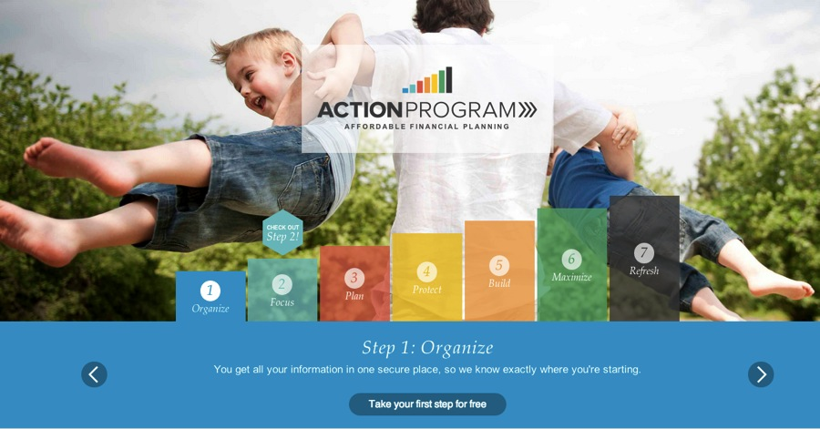

www.learnvest.com

* **Fourth module: Lenders we work with**
  + **Header:** Lenders we work with include:
  + **Module:** Scroll through lender logos (provided to Dan)

* **Fifth module: News / Reviews**
  + *This section will initially have testimonials, but will eventually be expanded to also include press.*
  + **Header:** But don’t take our word for it…
  + **Module:** Scroll through 5 testimonials
    - You made our seemingly impossible task of closing on time go very smoothly. -Sangeeta
    - You have set the benchmark, not just for customer service but unrivaled value and honesty. -Robert
    - My real estate agent tried to sway me to a local bank. Well, that wasn't needed, and it would have cost me a ton of money. -Mary
    - Extremely competitive rates and fees drew us to Sindeo, honest professionalism kept us. -Joel
    - From paperwork to people you have it covered. I appreciate the dedication of your staff. -Peter
  + **References:**



[www.learnvest.com](http://www.learnvest.com)



[www.moneypark.com](http://www.moneypark.com)

**Menu Option 1 – Learn**

* *The Learn section should have a horizontal line of links at the top of the page that jumps to each of the modules* 
  + Mortgage Profile Builder
  + Mortgage Types
  + Today’s Rate
* **Header:** Resource Center
* **First module: Mortgage Profile Builder**
  + *Land on page that asks one question at a time and provides big buttons/fields for person to answer. Form should be designed to be highly visual and convey the most information with the least amount of text.*
    - *Navigation should be done with a visual of an arrow pointing forward (and an arrow pointing backwards once you pass the first question)*
    - *The progress bar should fill up as each question is answered, but not show any other numbers*
    - *Form fields should be big buttons, sliders or number fields that automatically format the number correctly (i.e. if you enter 100000, it should format it to be $100,000).*
    - *As each question is answered, the answer should be added to a profile on the upper right hand side (see reference 2)*
  + Reference 1:

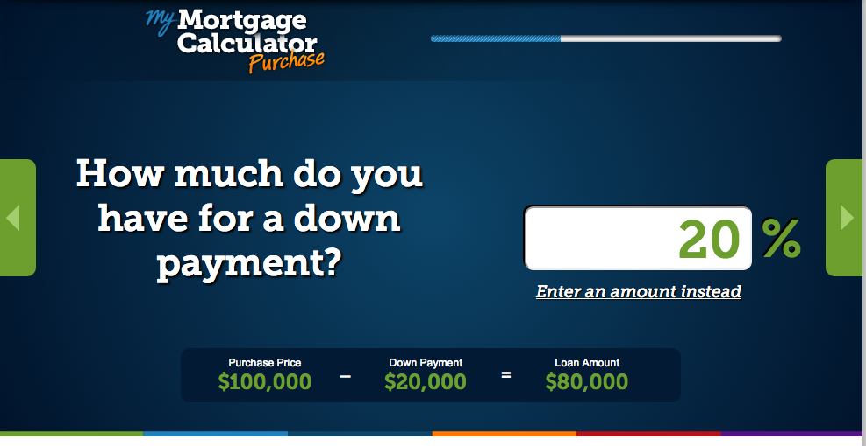

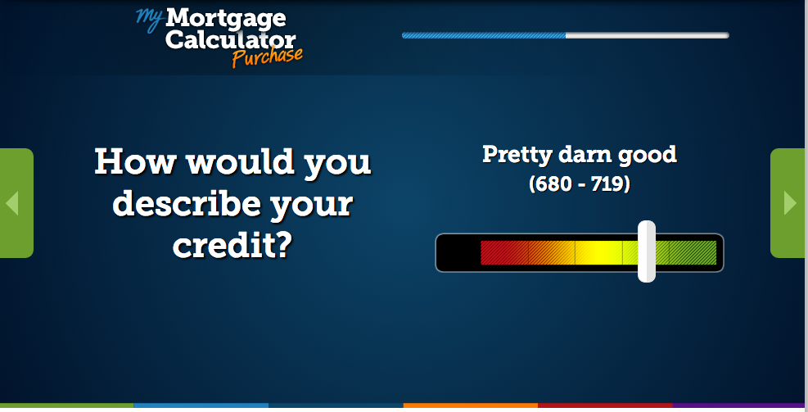

https://www.quickenloans.com/my-mortgage/calculator#!/purchase/question/down-payment

* + Reference 2

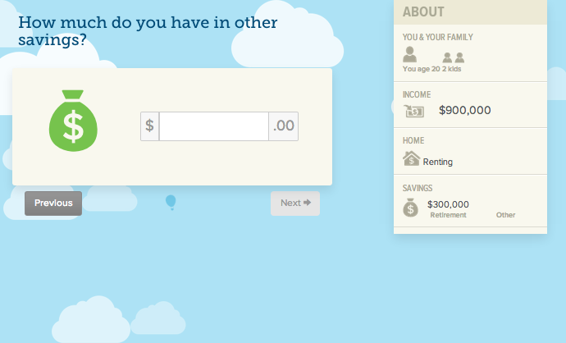

https://my.hellowallet.com/PublicHWWebApp.html#Score

* + **Questions:**
    - **What would you like to do?**
      * *Big buttons with text*
      * Purchase
      * Refinance
    - **Answers Purchase**

1. **What is your timing to purchase?**
   * + - * *Four vertical options with a circle button next to each*
         * Just researching my options
         * Buying in the next 3 months
         * Closing in / offer submitted
         * Purchase contract in hand
2. **What type of purchase is this?**
   * + - * *Four vertical options with a circle button next to each*
         * First Time Homebuyer
         * Selling Home/Moving
         * Second Home/Vacation Home
         * Investment Property
3. **Where are you looking?**
   * + - * Zip Code: Open entry *(Automatically populates county, city and state below)*

- or -

* + - * + State: Open entry with pre-populated suggestions for state
        + *If anything other than CA selected, take them to new screen that says “Our licensing for your state is currently pending. Give us your information and we’ll reach out to you as soon as we’re licensed.” Form field for name, phone and e-mail*

1. **What is the property value?**
   * + - * *Open entry. Entry formatted to $#,###,###,###*
2. **How much will the down payment be?**
   * + - * *Toggle switch flips between two options*
         * Percentage: Open entry, formatted to ##%
         * Value: Open entry, formatted to $#,###,###,###
3. **What is your credit rating?**
   * + - * *Slider (gradient - red on left, green on right)*
         * <500
         * 500-579
         * 580-619
         * 620-679
         * 680-719
         * 720+
     + **Answers Refinance**
4. **Why do you want to refinance?**
   * + - * Lower mortgage payments
         * Tap into equity/cash out
         * Lower interest rate
5. **Where is your property located?**
   * + - * Zip Code: Open entry *(Automatically populates county, city and state below)*
         * *If anything other than CA selected, take them to new screen that says “Our licensing for your state is currently pending. Give us your information and we’ll reach out to you as soon as we’re licensed.” Form field for name, phone and e-mail*
6. **What type of property is it?**
   * + - * *Four vertical options with a circle button next to each*
         * Single family residence
         * ###
         * ###
         * ###
7. **How much do you owe on your mortgage?**
   * + - * *Open entry. Entry formatted to $#,###,###,###*
8. **How much is your home worth today?**
   * + - * *Open entry, formatted to $#,###,###,###*
9. **What is your credit rating?**
   * + - * *Slider (gradient - red on left, green on right)*
         * <500
         * 500-579
         * 580-619
         * 620-679
         * 680-719
         * 720+
       - **Results Output**
         * *Your Mortgage Profile*
         * *Loan To Value Ratio & Affordability*
         * *Number of lenders (with logos)*
         * *Rates and Payments*
       - **Subhead:** Your mortgage profile is almost complete! We need a little more information for our advisors to be able to help you find the right mortgage.
       - Your Information
         * *Form fields*
         * First and Last Name:
         * E-mail:

Check box next to text that says “I’d like to stay up to date by adding myself to Sindeo’s mailing list.”

* + - * + Phone:
        + Button: Submit
        + We’ll also e-mail you a copy of your profile!
      * Reference:

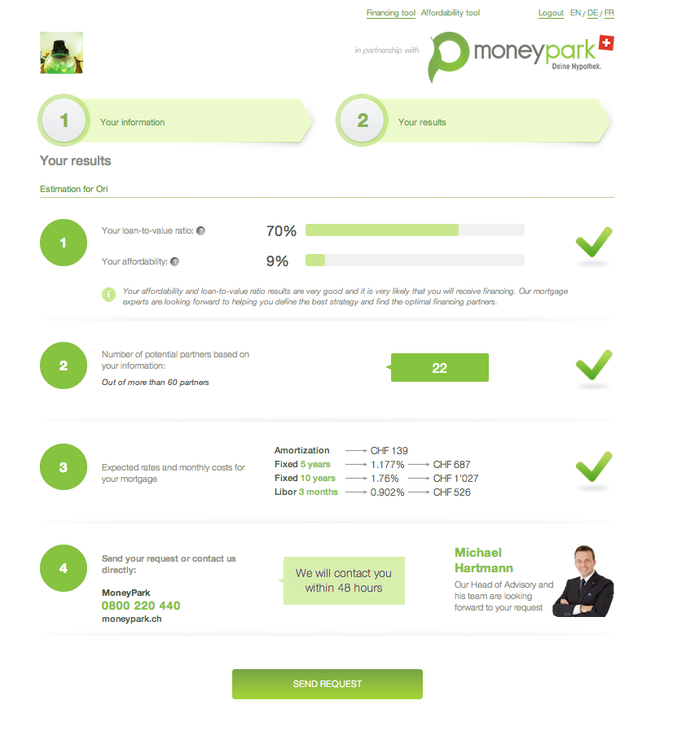

<https://affiliates.beta.mymoneypark.com/en/property-partners-tool/result/567>

(password protected – Ori can provide password)

* **Second module: Mortgages Types**
  + *Module that shows the different mortgage types. Initially only have Base programs showing, with the text below them collapsed. Click on the program title reveals the text below it.*
  + *Specialty Programs should also start collapsed. Clicking on Specialty programs shows all of the programs below it. Clicking on the programs shows the description.*
  + **Header:** Mortgage Types
  + **Subhead:** Get educated on all the different type of mortgages out there.
  + **Mortgage Types Module:**

**Base Programs [We will be updating the descriptions below]**

* **Conforming/Conventional**

Conforms to Fannie Mae and Freddie Mac’s guidelines, with a maximum loan size of $417,000 for a single-family home. The majority of home loans fall into this category.

* **Non-conforming/Jumbo**

Loans above conventional conforming loan limits, $417,000.

* **FHA**

Allows first time homebuyers to put down as little at 3.5% of total home value.

* **VA**

For eligible American veterans or their surviving spouses.

* **USDA**For rural property owners.

**Specialty Programs**

* **Down Payment Assistance Programs**For homebuyers, particularly first time homebuyers, that need support making their down payment.
* **FHA Streamlined 203K/Rehabilitation**For homebuyers and homeowners who need to finance property repairs or improvements.
* **Portfolio Lending**For borrowers that do not qualify for a loan through a government sponsored enterprise (GSE).
* **HELOC (Home Equity Line of Credit)**For homeowners seeking to free up cash based on home equity stake.
* **Third module: Today’s Rates**
  + **Header:** Today’s Rates
  + **Subhead:** Thecurrent mortgage rates are at a historic low, which is why buying a home and refinancing today may be a smart financial decision. Of course, the mortgage rates might rise again in the near future. Our advisors are here to help you to find the mortgage with the best rates out of all of the lenders we work with.
  + **Today’s Rates Module**
    - Our mortgage rate history tool shows you the change in rates for different mortgage types time.
    - MORE INFO TO COME
  + **Reference:**

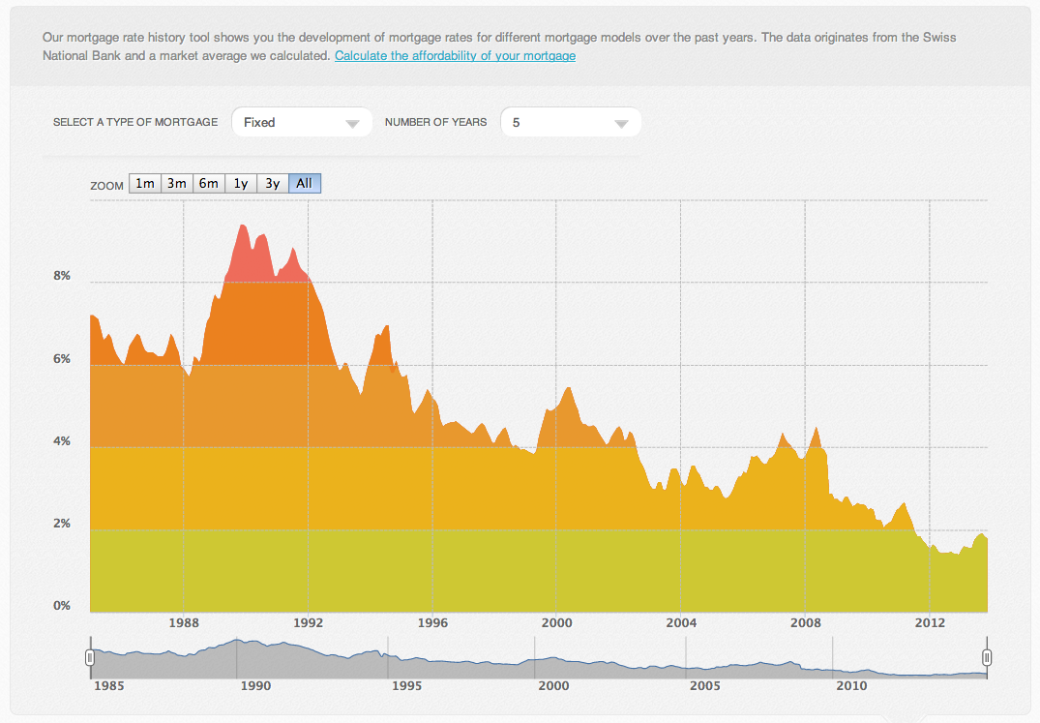

https://moneypark.ch/en/mortgage/rates/

**Menu Option 2 – Apply**

* *Show same contact box shown at top of home page:*
* **First module: Page Intro**
  + **Header:** A better way to get a mortgage. Now in California.
  + **Sub-head:** At Sindeo, we believe that getting a mortgage doesn’t need to be such a pain. That’s why we’re reinventing the mortgage process to get you the most competitive rates in the shortest amount of time. Peace of mind included. Spend 5 minutes with our advisors today:
    - **Box 1:** Call us at 1-855-SINDEO1 (746-3361)
    - **Box 2:** Have us contact you:
      * *To create a clean form, all form fields do not need titles, but the text in grey that disappears when you click into the box.*
      * Form field 1 – First and last name (free entry)
      * Form field 2 – Phone number (free entry of a 10 digit number formatted as a phone number i.e. (646) 276-5342, text appears in red if not a valid phone number)
      * Form field 3 –E-mail address (free entry, appears in red if not a valid e-mail)
      * Form field 4 – I want to: (radio buttons)
        + Purchase a home
        + Refinance a mortgage

If Refinance selected, two more options pop up below: Change Rate, Cash Out (radio buttons)

* + - * Form field 5 – Timing:
        + Need a mortgage now!
        + Actively shopping
        + Just researching
      * Button - Submit

**Menu Option 3 – About**

* *The About section should have a horizontal line of links at the top of the page that jumps to each of the modules* 
  + Our Mission
  + Areas We Serve
  + Meet Our Advisors
  + Leadership Team
  + Careers
  + Contact Us
* **First Module: Our Mission**
  + *Text from Our Mission should be displayed*
  + *Each core value should only show the icon and the name, and text is displayed by clicking/hovering over it*

OUR MISSION

Getting a mortgage can be a confusing and time consuming process. Sindeo is getting ready to fundamentally transform the mortgage experience. We combine the largest marketplace of quality lenders, knowledgeable service-driven advisors, and the most advanced technology platform in the industry. Sindeo will bring integrity, convenience, and service to mortgages.



Integrity

We are an independent and objective mortgage company. We ensure that all our associates and partners operate at the highest ethical standards and always put our clients’ needs first. We provide complete transparency across every step of the mortgage process and employ the highest compliance and data security standards to make sure sensitive personal information is safe.

Convenience

We are building the largest marketplace of quality lenders with the best information, tools, and advisors. We make working with us easy – with convenient branches, home/office visits, a robust online platform, mobile apps, and 24/7 phone support. We understand that time is critical and will always work to our clients’ timetable.

Service

We are committed to service excellence and delivering a great experience at every touchpoint. We believe exceptionally talented people equipped with the right tools and technology are the difference between a good and great experience. We are committed to training, developing and empowering our associates to be the most knowledgeable, friendly and effective consumer advocates in the mortgage industry.

* + **Reference:** <http://sindeo.com/about/>
* **Second Module: Areas We Serve** 
  + **Header:** Areas We Serve
  + **Sub-head:** We ###
  + **Who We Serve Module:** Map of the US with CA colored in
* **Third Module: Meet Our Advisors**
  + **Header:** Meet Our Advisors
  + **Sub-head:** Our advisors know how to get it done right. They collectively have closed billions of dollars of mortgages and have won countless awards. Get to know them:
  + **Advisor Module:** 
    - *Display name and title of each advisor. Roll over pulls up a few bullet points on advisors and images of licensing, awards, etc.*
    - *Format:*

First Name Last Name  
*Title*

Branch

* Qualifications
* Education
* Fun Fact
* Licensing (clickable logo + text)
* Accreditations (clickable logo)

Contact (each bullet below represented by an icon)

* E-mail
* Phone
* Fax
* Chat now
  + - *Example:*

Christopher Hussain  
*Founder, President of Mortgage Operations*

Branch: San Francisco

* #1 Mortgage Originator in US in 2010, 2011
* Personally originated $1+ billion in mortgages
* More than 10 years expertise in mortgage lending
* B.S. in Managerial Economics, UC Davis
* Master Taekwondo instructor, rare craft beer collector
* **[*238742*](http://nmlsconsumeraccess.org/EntityDetails.aspx/INDIVIDUAL/238742) ** [*01781678*](http://www2.dre.ca.gov/publicasp/pplinfo.asp?License_id=01872276)

Contact:

* E-mail: [Christopher@sindeo.com](mailto:Christopher@sindeo.com)
* Phone: 415-990-8190
* Fax: 1-800-810-6575
* Chat now
  + **Reference:**

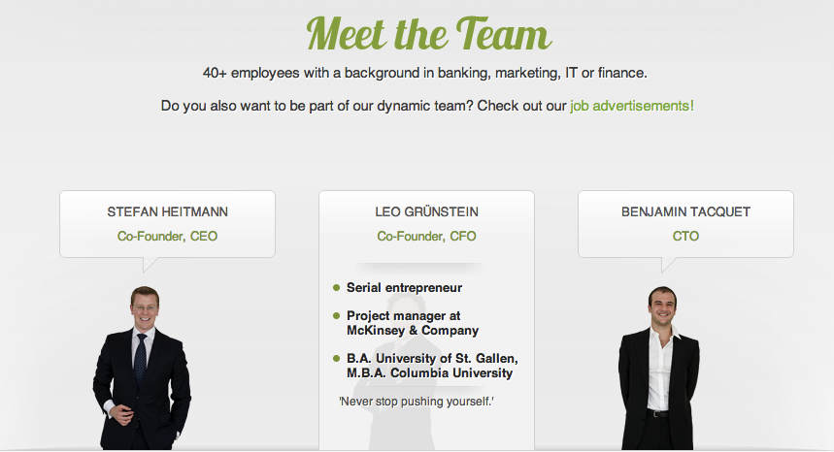

https://moneypark.ch/en/what-is-moneypark/

* **Fourth Module: Leadership Team**
  + **Header:** Leadership Team
  + **Sub-head:** Meet the team that launched this enterprise
  + **Founder Module:**

Nick Stamos  
*Founder, CEO*

* Successful entrepreneur in the mobile information space
* Managed global strategy, partnerships, and M&A at Nielsen
* Consultant for Swander, Pace & Company
* B.S. in Management, MIT
* First generation Greek-American, history and sports enthusiast

Christopher Hussain  
*Founder, President of Mortgage Operations*

* #1 Mortgage Originator in US in 2010, 2011
* Personally originated $1+ billion in mortgages
* More than 10 years expertise in mortgage lending
* B.S in Managerial Economics, UC Davis
* Master Taekwondo instructor, rare craft beer collector

Ori Zohar  
*Founder, Marketing*

* Background as a New York Ad Man
* Past clients include MasterCard, Coca Cola, Intel
* Lecturer on Digital and Emerging Media Platforms
* B.S. in Marketing, University of Maryland
* Avid eater, cook and runner

Glenn Tatarsky  
*EVP, Business Development*

* TBD
* TBD
* TBD
* TBD
* TBD
* **Fifth Module: Careers**
  + **Header:** Careers
  + **Sub-head:**

We’re always looking for strategic thinkers, intrepid creators  
and mortgage ninjas to join our growing team.

We’ll post opportunities on this page as they become available, but feel free to get in touch with us.

* + **Job listing module:**
    - **Header:** Job Openings
    - *Include module where we can easily post and take down job openings. Same content and functionality as the one currently used by MoneyPark:*

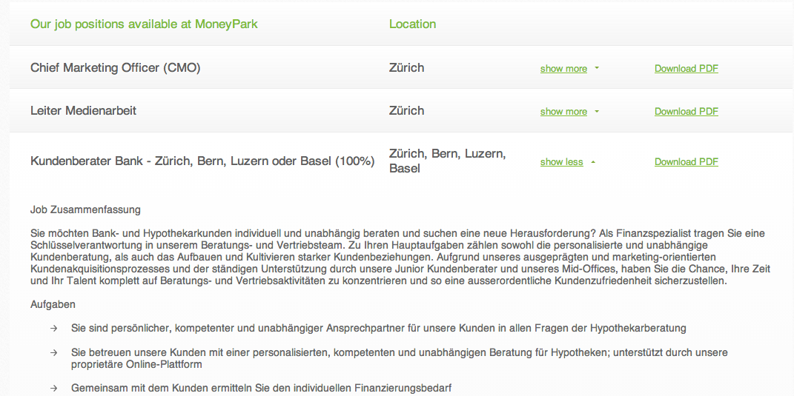

https://moneypark.ch/en/career/

* **Sixth Module: Contact Us**
  + **Header:** Contact Us
    - **Visit our branch:**   
      180 Sansome Street, 15th Fl  
      San Francisco, CA, 94104  
      *Show location of branch on Google Maps*
    - **Call us:** 1-855-SINDEO1 (1-855-746-3361)
    - **E-mail us**: [info@sindeo.com](mailto:info@sindeo.com)
    - **Send us a message:**
      * Contact form (first and last name, e-mail, phone, message)
  + **Reference:**

 http://www.sindeo.com/contact/